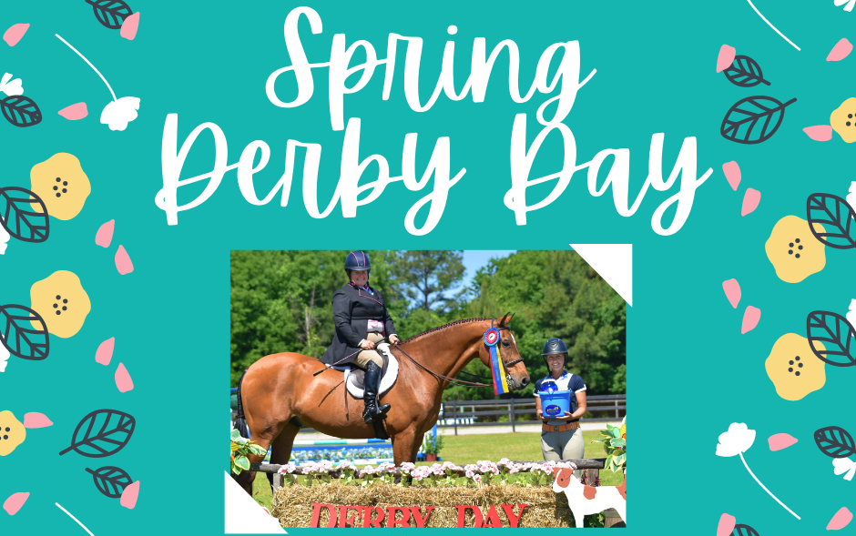
The Farm at One Under Lane’s
2022 Derby Day Sponsorship Info

The Farm at One Under Lane’s Derby Day horse shows are unique events unlike any other hunter/jumper horse show out there. We offer standalone hunter and jumper derbies, as well as equitation classes, for all levels from beginners to advanced competitors. Our 2020 and 2021 events took place on our beautifully decorated grass arena with eye-catching jumps and challenging courses. Beyond the excitement of the competition itself, though, is what makes Derby Day truly unique: riders receive written feedback from the judge on every round. This provides competitors with not only an exciting horse show experience, but also with invaluable knowledge and education to improve their riding and skills. New for 2022, our shows are now sanctioned by The Jockey Club’s Thoroughbred Incentive Program, providing riders the opportunity to quality for the program’s National Championship! Derby Day shows also feature vendor spaces, complimentary lunches, and trainer gift bags. We set out to make it an experience that competitors won’t forget, and will be excited to put on their calendars for spring and fall!

We anticipate at least 50 participants in our Spring Derby Day, not including their family members and friends who will accompany them. Our 2020 and 2021 Derby Day horse shows were a great success and our exhibitors were absolutely floored by the quality of the prizes we were able to give, thanks to our fabulous sponsors! We hope you’ll join us for our first event of 2022 and help us run another wonderful show while we help promote and support your businesses. Below is a list of ready-made sponsorship opportunities. If you have something else in mind, please reach out and allow us to create a package that works for you.

Tricolor Sponsor $300+
This sponsorship level is a general sponsorship, where sponsor funds will be allocated where they are most needed for the quality of the horse show. A highly-anticipated class will be named for the sponsor, and sponsors are best remembered by exhibitors if the sponsor provides a prize with their logo or a certificate for a service or item.
What will we do for you? Sponsor listed in prize list and on promotional material, advertisement in arena with a banner or sign, mentions on social media and throughout the show day, advertisement in trainer gift bags, waived vendor fee.

Blue Ribbon Sponsor $200
A class will be named for the sponsor, and may be supported by more than one sponsor. It is appreciated if the sponsor provides a prize or a certificate for a service or item.
What will we do for you? Sponsor listed in prize list, mentions on social media and throughout the show day, vendor fee waived, and advertisement in trainer gift bags. Banners/signs will be displayed if provided by sponsor.

Prize Sponsor
This sponsorship level is for those who may which to contribute prizes, or funds ($50-$100) to purchase prizes. In the past, we have had businesses at this sponsorship level supply gift bags, saddle pads, tack cleaning sets, and certificates for services or items among others. Monetary contributions for the purchase of ribbons are welcome, too!
What will we do for you? Sponsor listed in prize list, mentions on social media and throughout the show day, and advertisement in trainer gift bags.

Special Award Sponsor
At our Derby Day shows, we enjoy giving special awards as well for Best Child Rider, Best Turned Out Horse, and Highest Scoring Horse. We are also open to additional awards! As a special award sponsor, the sponsor would provide a prize for one of these (or another) special award.
What will we do for you? Sponsor listed in prize list, mentions on social media and throughout the show day, and advertisement in trainer gift bags.

Vendor
Vendor spaces are a win-win for everyone at the horse show! Businesses get their name out and about and can capitalize on a captive audience on show day, while exhibitors enjoy shopping between rounds. Interested in a vendor space at Derby Day? We would love to have you! Vendor spaces are $75 for the day if not a sponsor, and $30 for the day if also sponsoring the show. Some sponsorship levels include vendor spaces.

Interested? We hope so! Please reach out to show manager Maddy Brown via email at maritimeeq@gmail.com to discuss how you can become a part of Derby Day!

